***Relogger GUIDE***

1. ***first you begin relogger. exe in your Wrobot folder***

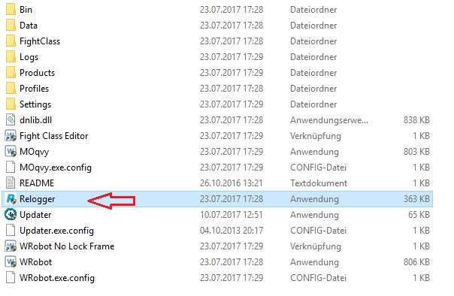

***2. after relogger is opened placed to the heels with Checked***

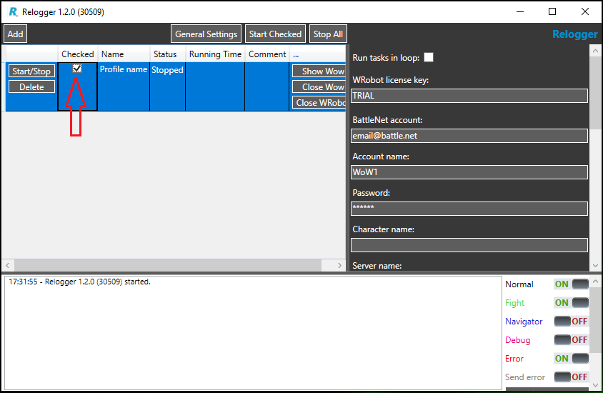

***3.Fill now on the right side all fields***

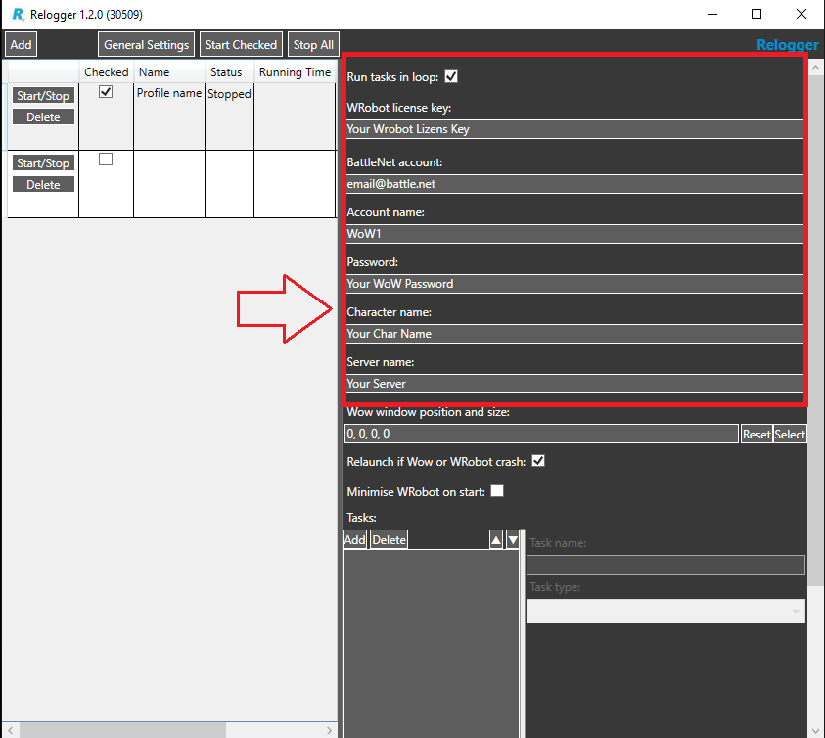

***4. Click 3 times on add***

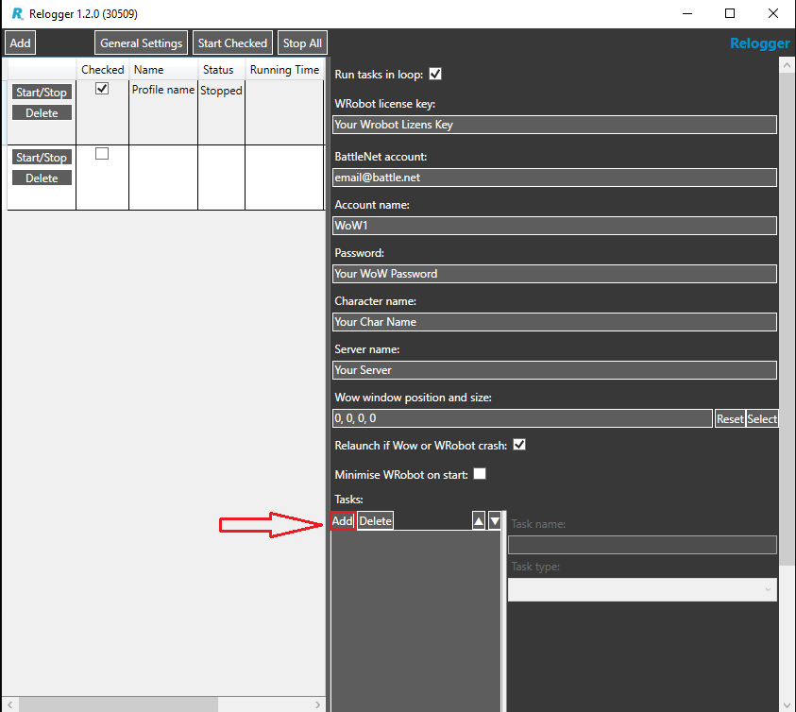

***5. then thus it should look***

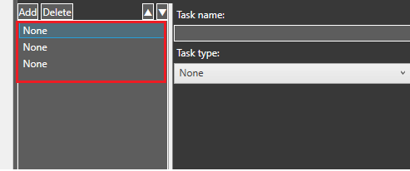

***Click on None 1  
  
Task name: enters Route 1.  
  
Task type: select Run***

***Product: select Gatherer  
  
Profiles: select the profiles I created: Route 1 Suramar  
  
FightClass: select your Fightclass  
  
When you finished click in None 2  
  
You will see that None 1***

***now changes to Run (Route 1)***

***changes if this repeats with every segment and respects to it you under profiles the suitable route chooses***

***None 1 = route 1 Suramar***

***None 2 = route 2 Suramar***

***None 3 = route 3 Suramar***

***6. if you ready to this should look so***

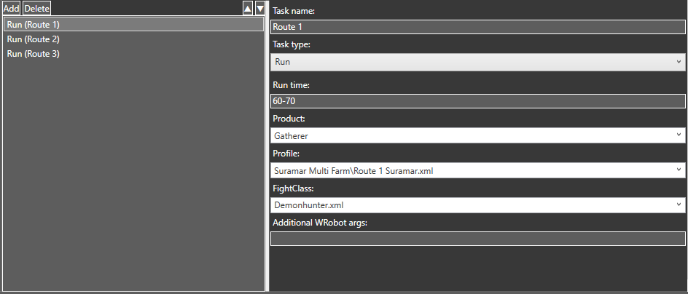

***7. Check the General Settings before starting***

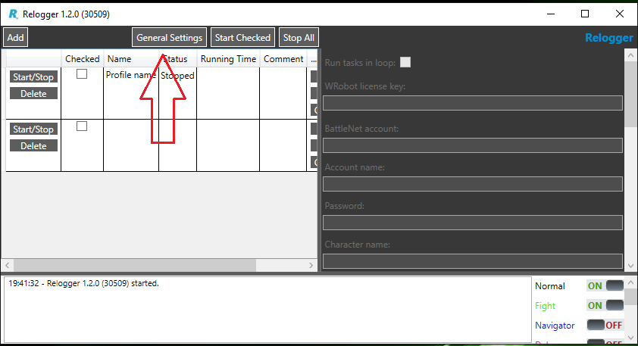

***Finish! Click on Start Checked***

***(Hack must be set at Checked)***